| **A** | **B** | **Cin** | **Sum** | **Cout** |  |
| --- | --- | --- | --- | --- | --- |
| 0 | 0 | 0 | 0 | 0 |  |
| 0 | 0 | 1 | 1 | 0 |  |
| 0 | 1 | 0 | 1 | 0 |  |
| 0 | 1 | 1 | 0 | 1 |  |
| 1 | 0 | 0 | 0 | 0 |  |
| 1 | 0 | 1 | 1 | 1 |  |
| 1 | 1 | 0 | 0 | 1 |  |
| 1 | 1 | 1 | 1 | 1 |  |
|  |  |  |  |  |  |

**Task 1:**

Sum = !A!BCin + !AB!Cin + A!BCin+ ABCin

Cout = !ABCin + A!BCin + AB!Cin + ABCin

K-Map

| !b1!b0 | !b1b0 | **b1b0** | **b1!b0** |
| --- | --- | --- | --- |
| 0: 0 | 1 | **3** | **2** |
| 1: 4 | 5 | **7** | **6** |

| !b1!b0 | !b1b0 | **b1b0** | **b1!b0** |  |
| --- | --- | --- | --- | --- |
| b2 |  | **1** |  |  |
| b2 |  | **1** | **1** |  |

Expression: B2+ (B1 * B0)

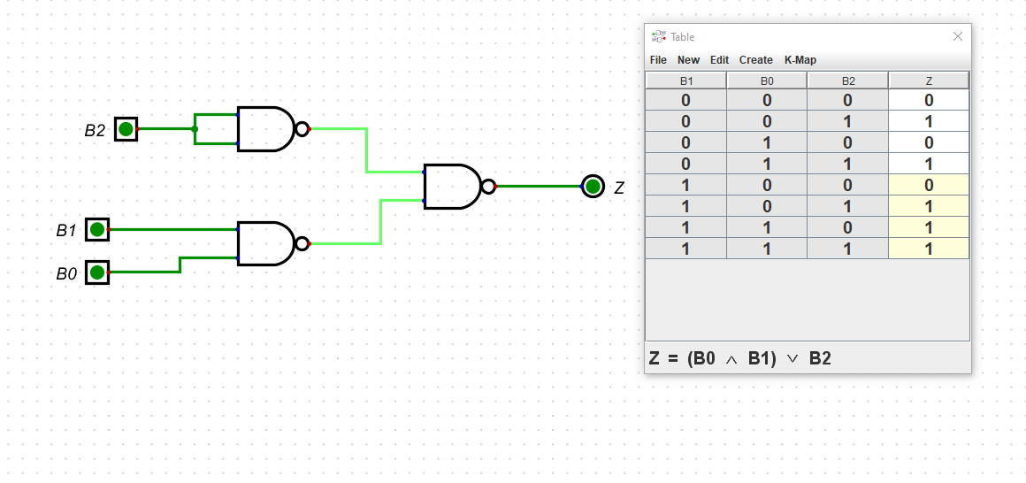

WHen both inputs are shorted NAND gates act as an inverter

We know that ~(A*B) = ~A+ ~B, in the same way ~((~b2)*(~b1*b0))

Therefore Z = B0 ^ B1 V B2

Three inputs for two variables so 2^3 =8

**Task 2:**

Output= A+B if inverse=0

= A + B' +1 = A-B if inverse= 1 since B'+1 is 2's complement of B i.e -B

Now if inverse=0, B XOR inverse=B and Output= A+B = A+B+0=A+(B XOR inverse) +inverse

if INV=1, B XOR inverse= B' and Output=A-B = A+B'+1=A+ (B XOR inverse) +inverse

In both cases Output is = **A+ (B XOR inverse) +inverse**

Hence each bit of the second number is **XOR’ed** with inverse and then added to A and inverse to get the output (as shown in schematic)

On the basis of this logic we get the following schematic diagram for a 4 bit adder/subtractor A3 A2 A1 A0 are bits of the first number( A3 is MSB) and B3 B2 B1 B0 are bits of the second number(B3 is MSB)

Difference with regular adder is that the bits of the second number is XORED with INV in adder-subtractor

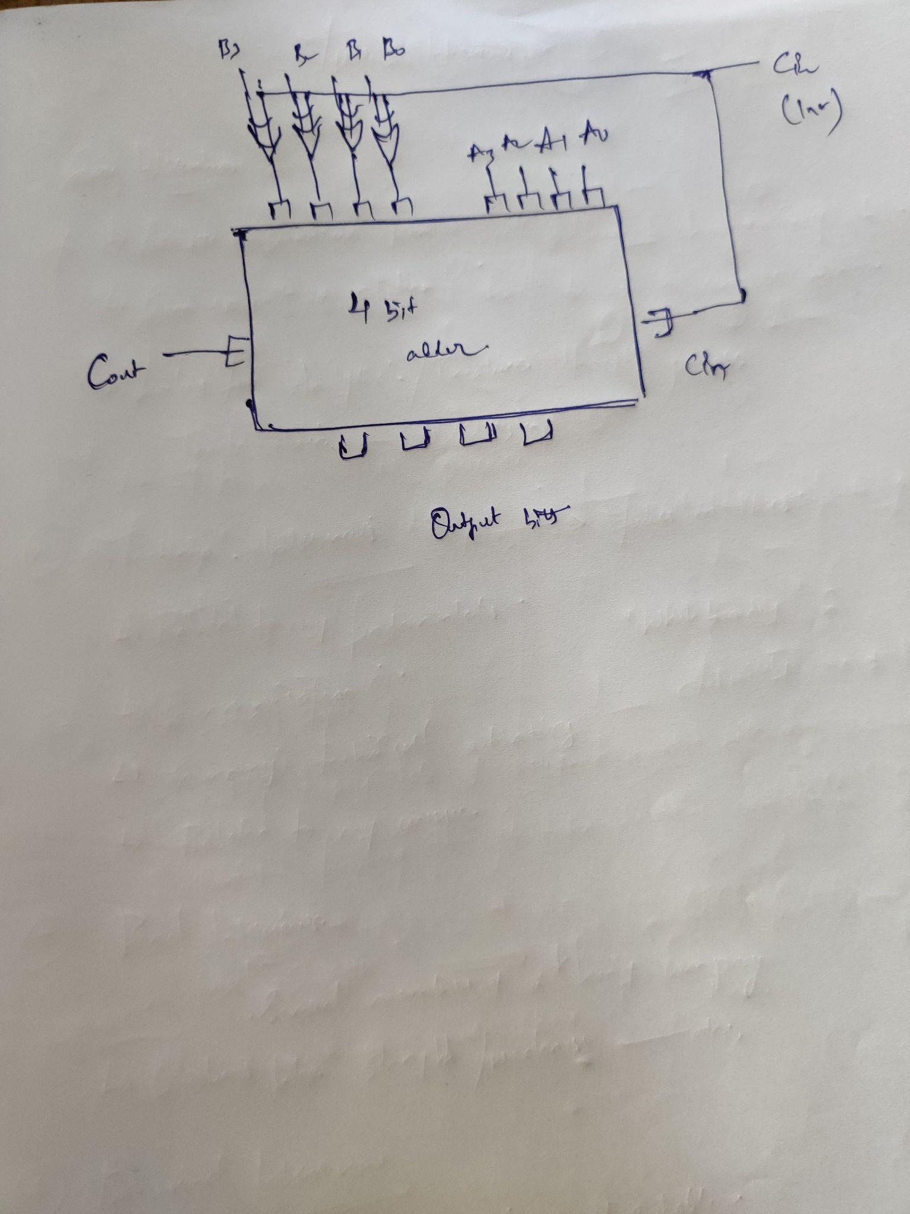

Test Scenarios:

A= 3 :0011

B=2: 0010

INV= 0 ,INV=1

(B0 XOR INV)=0 B0 | XOR INV=1

(B1 XOR INV)=1 B1 | XOR INV=0

(B2 XOR INV)=0 B2 | XOR INV=1

(B3 XOR INV)=0 B3 | XOR INV=1

Output= 0011 + 0010 =0101(5) =3+2

Output= 0011 + 1101 +1 = 0001(1)=3-2

Therefore when INV =0 it adds while when INV=1 it performs subtraction.